MIDTERM

What is Image Enhancement?

Process an image to make the result more suitable than the original image for a specific application (complete).

What are the types of image enhancement operations?

* Point/pixel operation: the output value at specific coordinates (x, y) depend only on the input value of (x, y).
* Local Operation: the output value at specific coordinates (x, y) depend on the input values in the neighborhood of (x, y).

In local operation g depends on the predefined number of neighbors of at (x, y) Implemented by using mask processing or filtering Masks.

What is Image enhancement methods?

Spatial domain: Direct manipulation of pixel in an image.

Frequency domain: Processing the image based on modifying the Fourier transform of an image. Hello heaven is killing him every column in very.

Spatial domain enhancement methods can be generalized:

g (x, y) = T [f (x, y)]

f(x, y): input image, g(x, y) output image, T [*] an operation on f (x, y)

Neighborhood about (x, y): a square or rectangular sub image area centered at (x, y)

What are 3 basic gray-level transformation functions?

Linear function: Negative and identity transformations

Logarithm function: Log and inverse-log transformation

Power-law function: nth power and nth root transformations

What is Identity Function?

* Output intensities are identical to input intensities.

What is Negative image?

* Negative images are useful for enhancing white or grey detail embedded in dark regions of an image

s =T(r) = (L - 1) – r

What are Logarithmic (Log) Transformations?

* The log transformation maps a narrow range of low input grey level values into a wider range of output values

What are Properties of log transformations?

* For lower amplitudes of input image the range of gray levels is expanded (Complete)
* For higher amplitudes of input image the range of gray levels is compressed (Complete)

s = c Log(1+r)

Log Transformations:

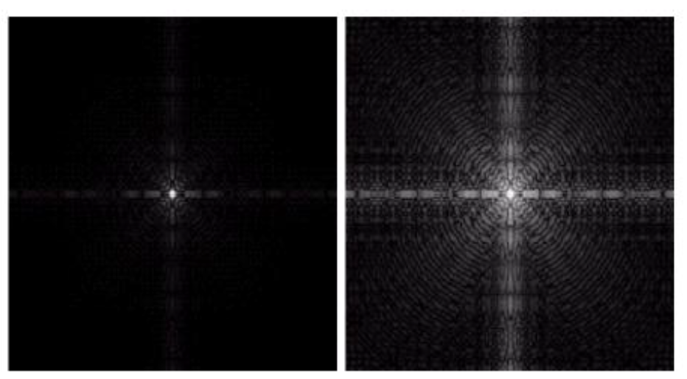

What are Inverse Log Transformations?

* Do opposite to the Log Transformations
* Used to expand the values of high pixels in an image while compressing the darker-level values.

What is Power-law transformation?

Map a narrow range of dark input values into a wider range of output values or vice versa.

s = c * rγ

For γ < 1: Expands values of dark pixels, compress values of brighter pixels.

For γ > 1: Compresses values of dark pixels, expand values of brighter pixels.

If γ=1 & c=1: Identity transformation (s = r)

What is Gamma (γ) correction?

* The process used to correct the power-law response phenomena

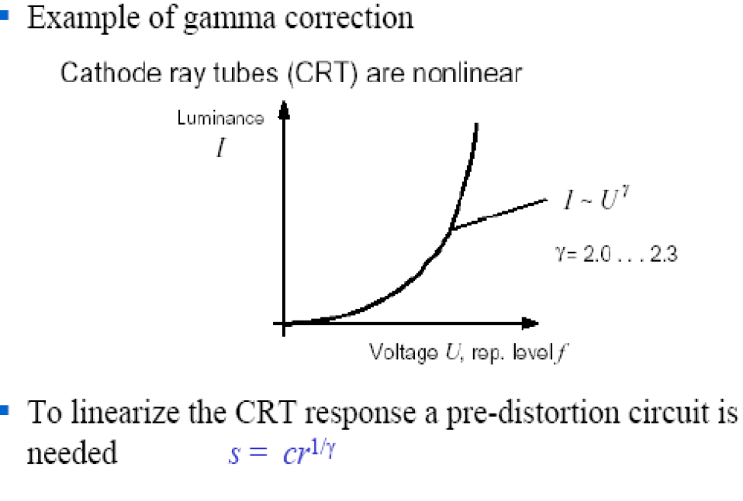

(complete) Gamma correction is done by preprocessing the image before inputting it to the monitor with s = cr1/Y

**Power-Law transformation: Example:**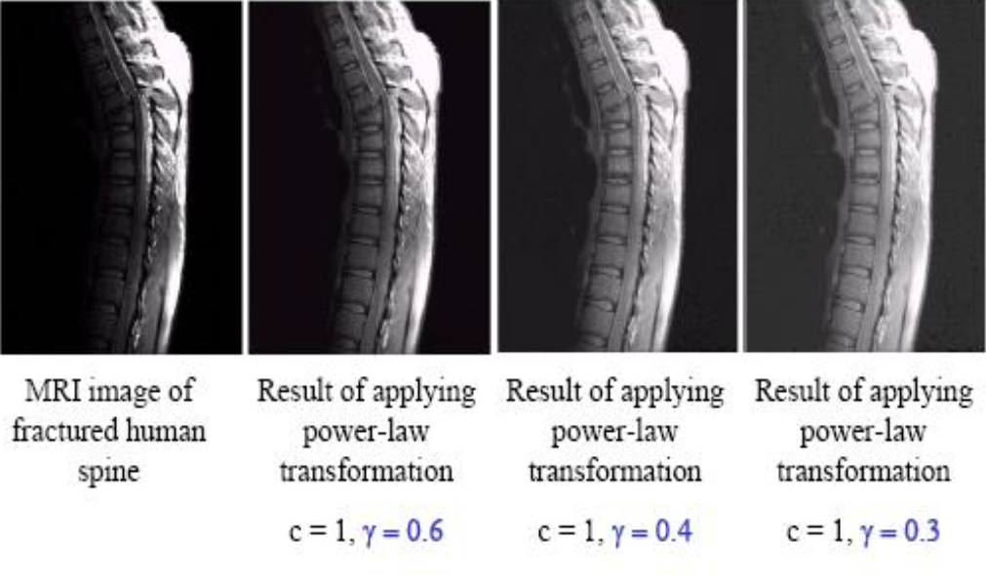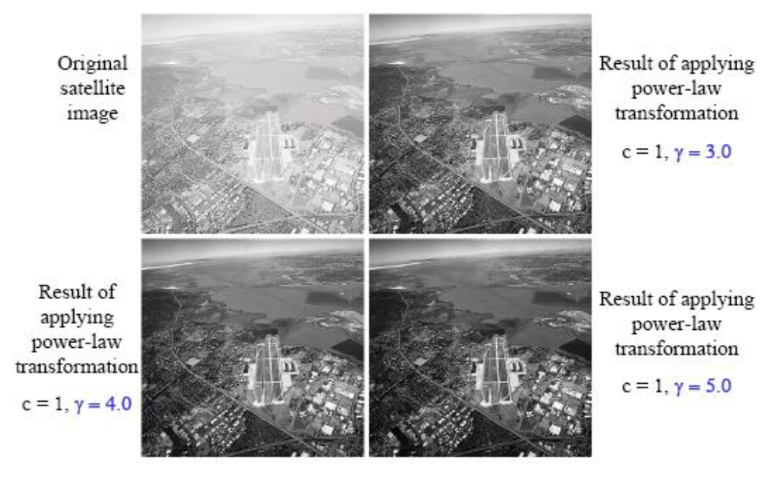

**Piecewise Linear Transformation: -**

**1- Contrast Stretching**

What is Contrast Stretching?

Increase the dynamic range of the gray levels for low contrast images

What can result from low contrast image? / what Couse the low contrast image?

* + poor illumination
  + lack of dynamic range
  + wrong setting of a lens aperture during image acquisition

Contrast Stretching Example:

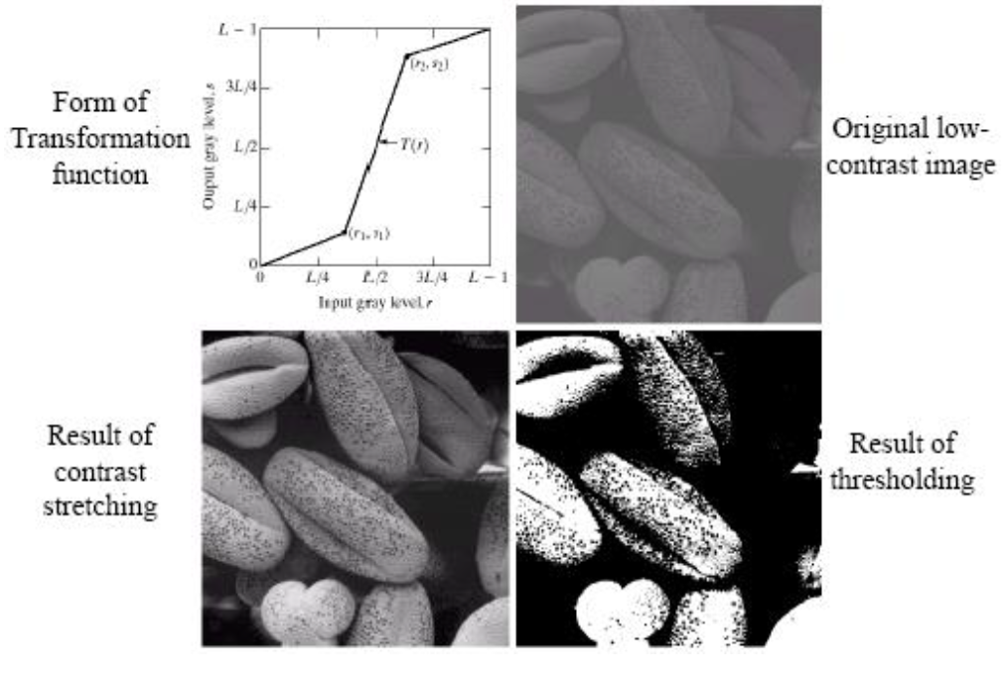

2- Gray-level slicing

What is Gray-level slicing?

* Highlighting a specific range of gray levels in an image.

-Display a high value of all gray levels in the range of interest and a low value for all other gray levels.

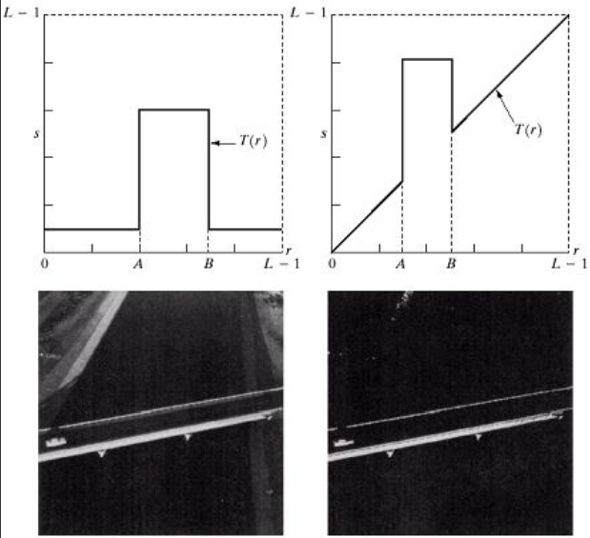

3- Bit Plane slicing: -

what is Bit Plane slicing?

* Highlighting the contribution made to total image appearance by specific bits
* Suppose each pixel is represented by 8 bits
* Higher-order bits contain the majority of the visually significant data
* Useful for analyzing the relative importance played by each bit of the image

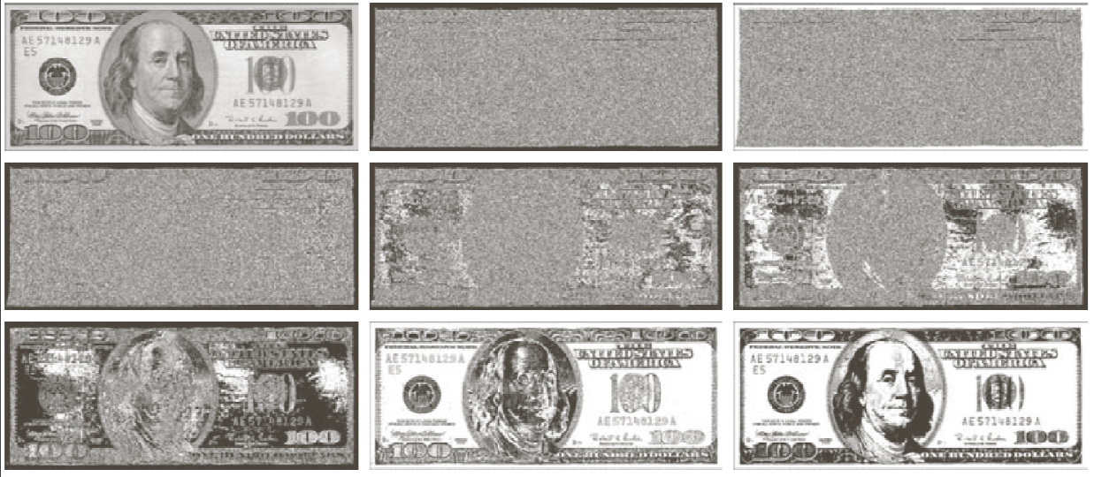Bit-plane slicing Example: 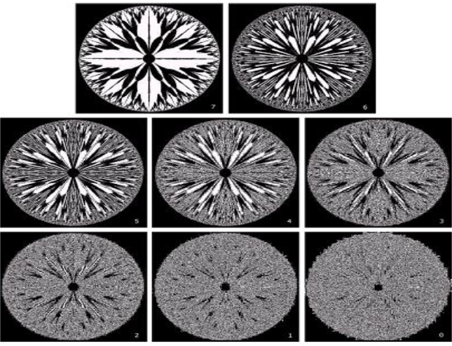

**Histograms**

Histogram of an image with gray level: - A discrete function h(rk)=nk, where rk is the gray level, nk is the number of pixels in the image.

How a histogram is obtained?

* for B-bit image, initialize 2B counters with 0
* loop over all pixels
* when encountering gray level *f (*x, y) = **I**, increment counter **I.**

What is a Normalized histogram?

A discrete function p(rk) = nk/n, where “n” is the total number of pixels in an image, p(rk) determines probability of occurrence of gray-level rk

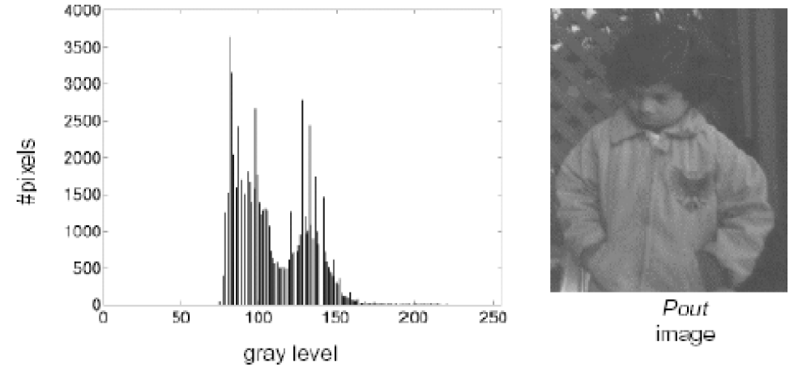

what is Contrast Stretching through Histogram?

* If rmax and rmin are the maximum and minimum gray level of the input image and L is the total gray levels of output image the transformation function for contrast stretching will be

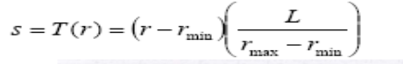

What is Histogram Equalization?

* Spreading out the frequencies in an image is a simple way to improve dark or washed-out images

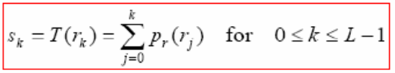

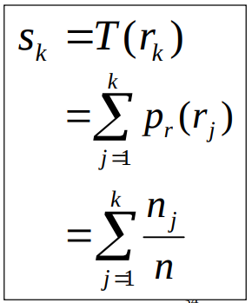

**Histogram Equalization: Example**

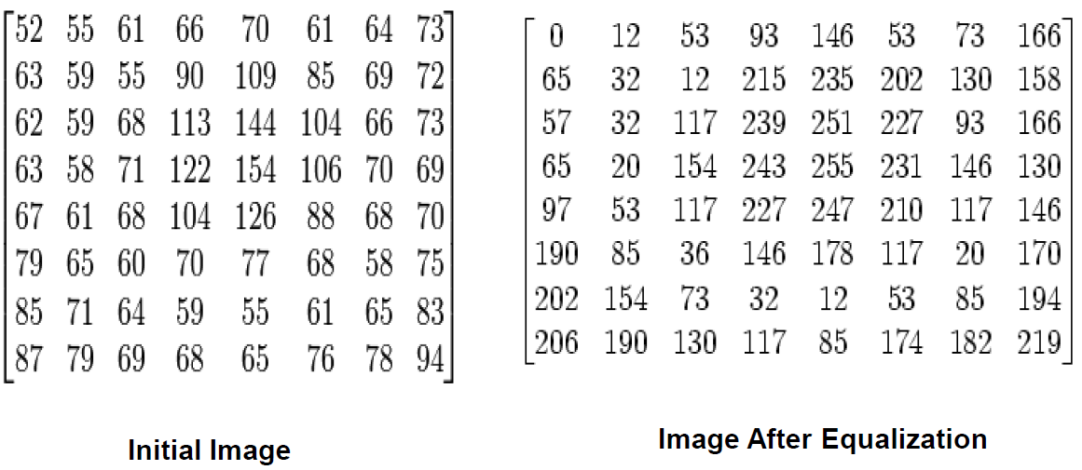

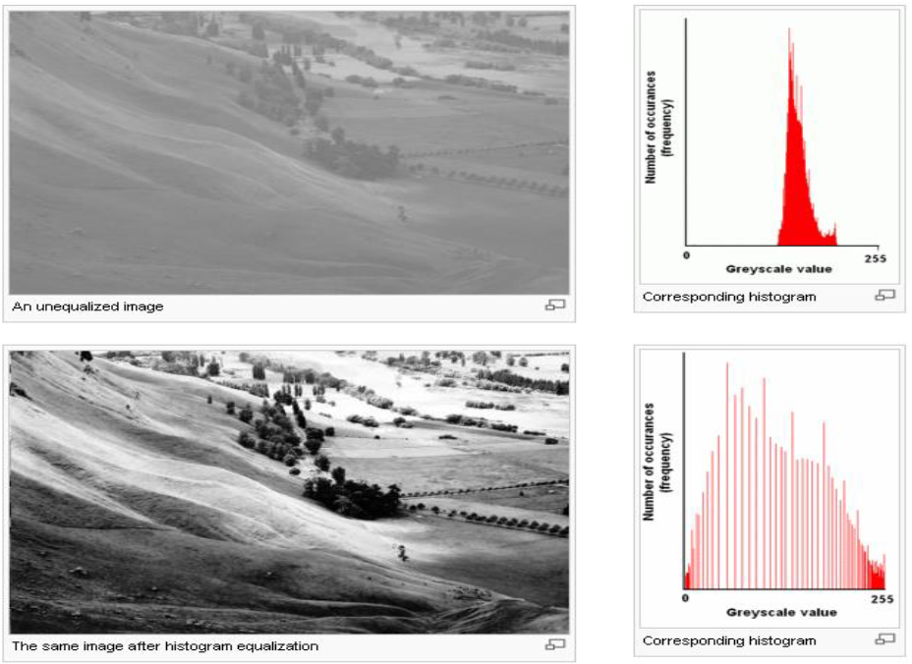

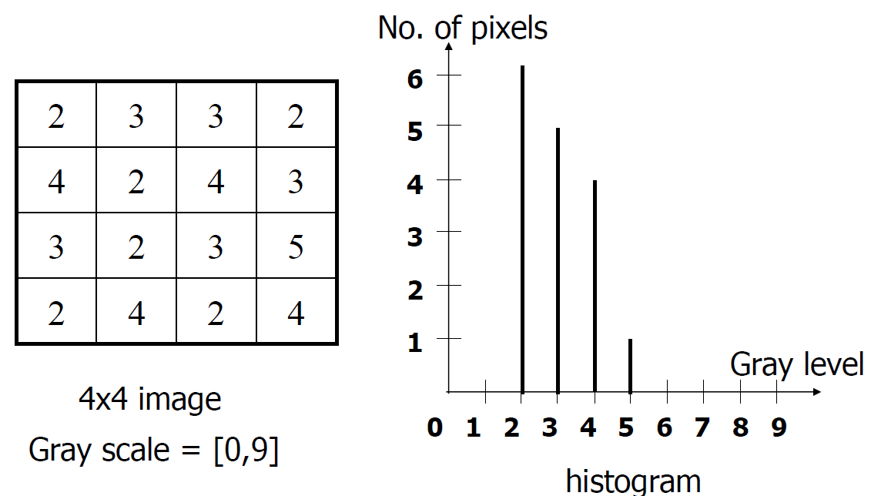

What are Neighborhood Operations?

* Neighborhood operations simply operate on a larger neighborhood of pixels than point operations.

what are Neighborhoods?

* Neighborhoods are mostly a rectangle around a central pixel

What is Local Enhancement?

The output intensity value at (x,y) depends not only on the input intensity value at (x,y) but also on the specified number of neighboring intensity values around (x,y).

Spatial masks are used and convolved يلتف over the entire image for local enhancement.

The size of the mask determines the number of neighboring pixels which influence the output value at (x,y).(complete)

The values (coefficients) of the mask determine the nature and properties of enhancing technique. (complete)

what are Simple Neighborhood Operations?

Min: Set the pixel value to the minimum in the neighborhood.

Max: Set the pixel value to the maximum in the

neighborhood.

Median: The median value of a set of numbers is the midpoint value in that set.

The above is repeated for every pixel in the

original image to generate the smoothed image (Complete)

Image Smoothing:

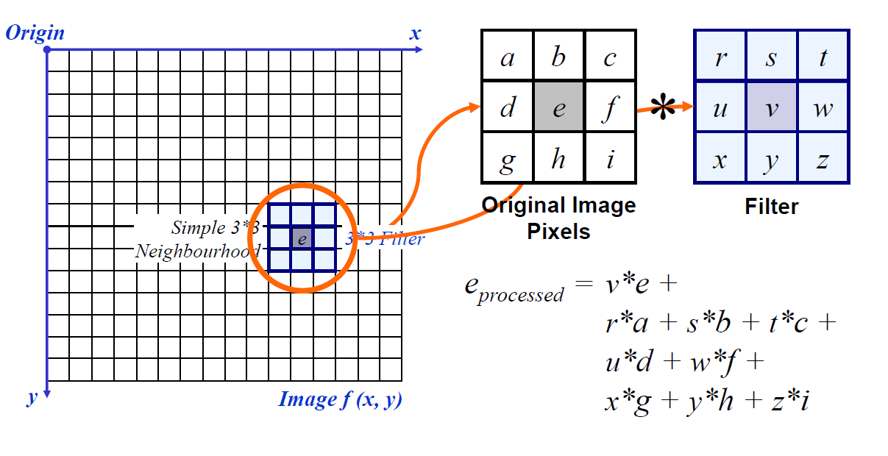

Special filtering:

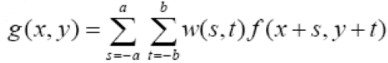

What is mask operation near the image border?

1. Discard تجاهل the problem pixels.
2. Zero padding: expand the input image by padding zeros.
3. We normally use the gray level of border pixels to fill up the expended region, for larger masks a border region equal to half of the mask size is mirrored on the expended region.

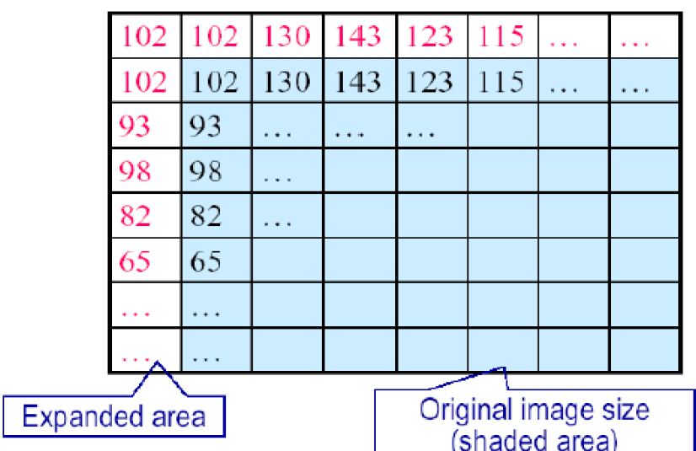

What is Smoothing Spatial Filters?

One of the simplest spatial filtering operations we can perform is a smoothing operation (Complete)

What is the use of Smoothing Spatial Filters?

* Especially useful in removing the noise forms an image (Complete)
* Useful for highlighting gross detail مفيد لإبراز التفاصيل الإجمالية (Complete)

Example of Spatial Filtering for Smoothing:

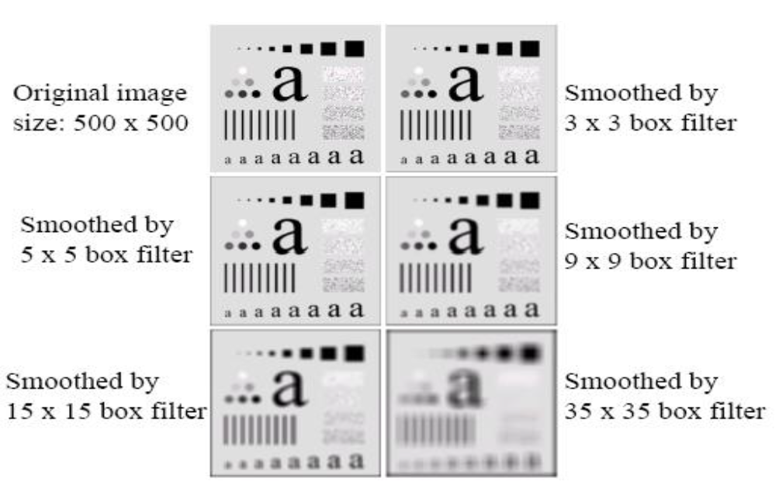

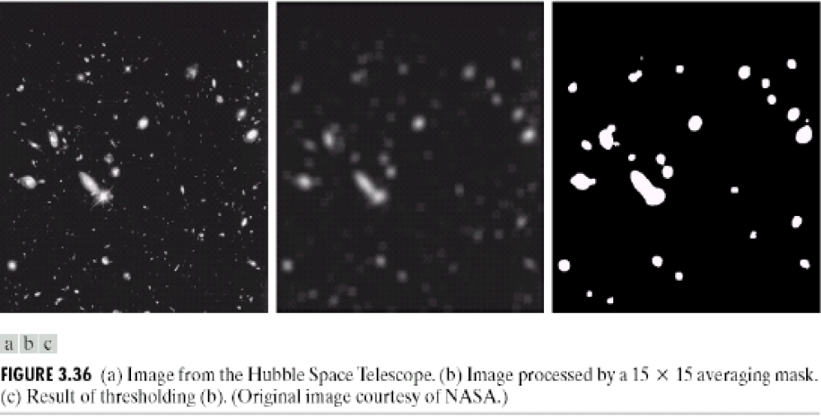

What is Weighted Smoothing Filters?

More effective smoothing filters can be generated by allowing different pixels in the neighborhood different weights in the averaging function.

Weighted smoothing filters Often referred to as a weighted averaging (Complete)

Pixels closer to the central pixel are more important (Complete)

Order Statistics Filtering

Filtering is often used to remove noise from images (complete)

What is Order Statistics Filtering?

Nonlinear spatial filters, its Output is based on order of gray levels in the masked area.

What are the types of order statistics filtering?

1. Median filtering
2. Max filtering
3. Min filtering

What is median filtering?

Assigns the mid value of all the gray levels in the mask to the center of mask.

When median filtering is practically effective? / what are the use of median filtering?

* Remove the noise pattern consists of strong, spiky components
* edges are to be preserved محفوظة

Median Filtering (Example):

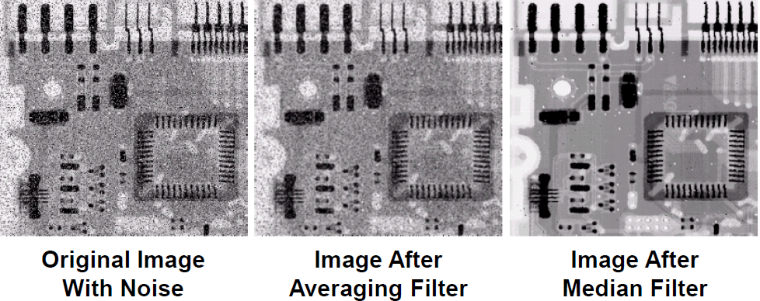

There are a few approaches to dealing with missing edge pixels explain?

* Omit حذف missing pixels.
* Pad ضم the image.
* Replicate border pixels.
* Truncate اقتطاع the image.
* Allow pixels wrap around the image.